SCHOOLOFCOMPUTER SCIENCE AND ARTIFICIAL INTELLIGENCE |  |  |  |  | DEPARTMENTOFCOMPUTER SCIENCE ENGINEERING
ProgramName:M. Tech/MSC/MCA |  |  |  | AssignmentType: Lab |  |  | AcademicYear:2025-2026
CourseCoordinatorName |  |  |  | Venkataramana Veeramsetty
CourseCode |  |  |  | CourseTitle |  | AI Assisted Coding
Year/Sem |  |  | I/I | Regulation |  | R25
DateandDay  of Assignment |  |  |  | Time(s)
Duration |  |  | 2 Hours | Applicableto  Batches
AssignmentNumber:17.3(Presentassignmentnumber)/24(Totalnumberofassignments)
 | Q.No. | Question |  |  |  |  |  | ExpectedTime  to complete
 | 1 | Lab 17 – AI for Data Processing: Data Cleaning and Preprocessing Scripts  Lab Objectives:  - Learn how to clean raw datasets using AI-assisted Python scripting.  - Apply preprocessing techniques such as handling missing values, encoding categorical data, and normalization.  - Automate repetitive data-cleaning tasks with AI-generated code.  - Understand how preprocessing impacts model performance.  Task 1 – Social Media Data Cleaning  Task: Clean raw social media posts dataset.  Instructions:  - Remove stopwords, punctuation, and special symbols from post text.  - Handle missing values in likes and shares columns.  - Convert timestamp to datetime and extract features (hour, weekday).  - Detect and remove spam/duplicate posts.  Expected Output: A cleaned dataset with structured features for sentiment/engagement analysis  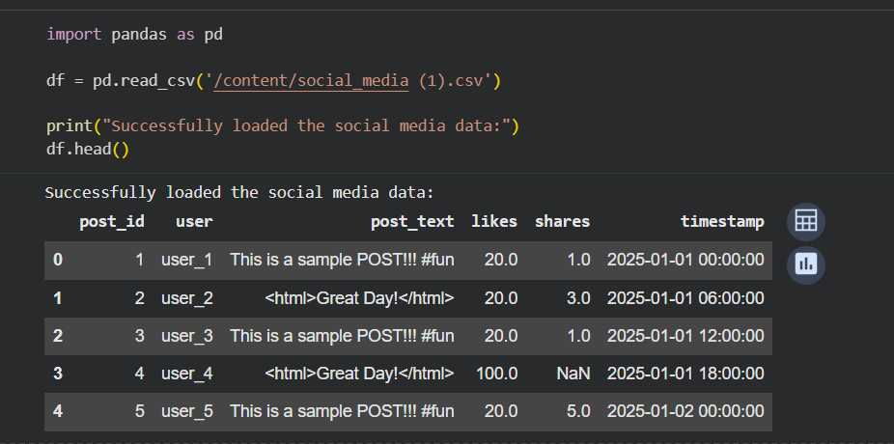  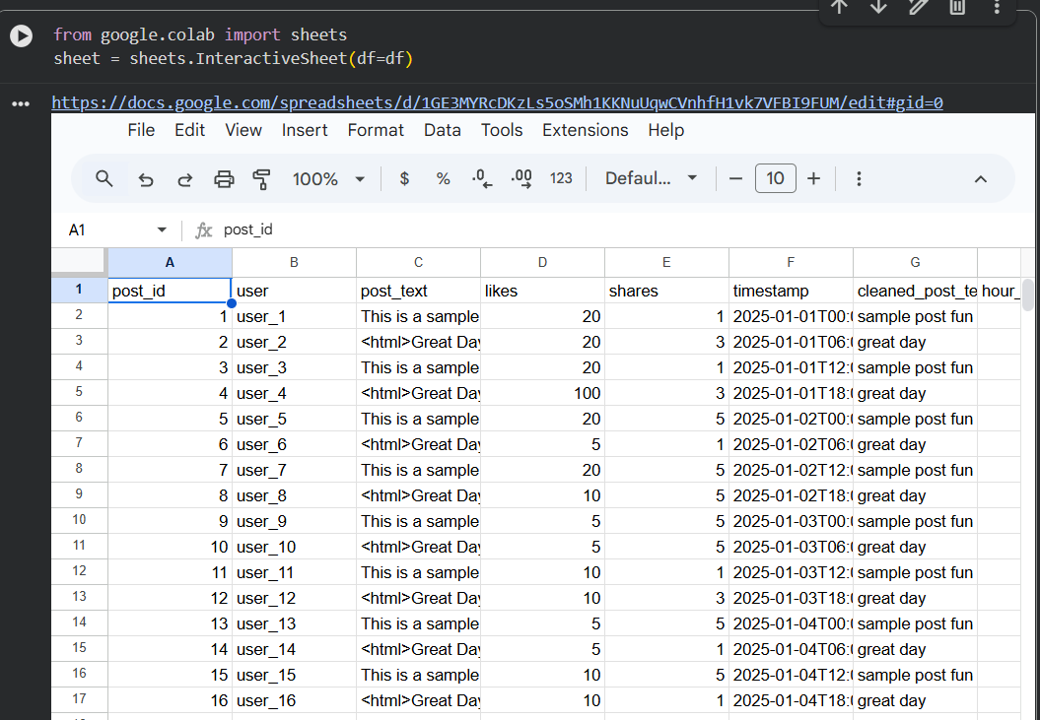  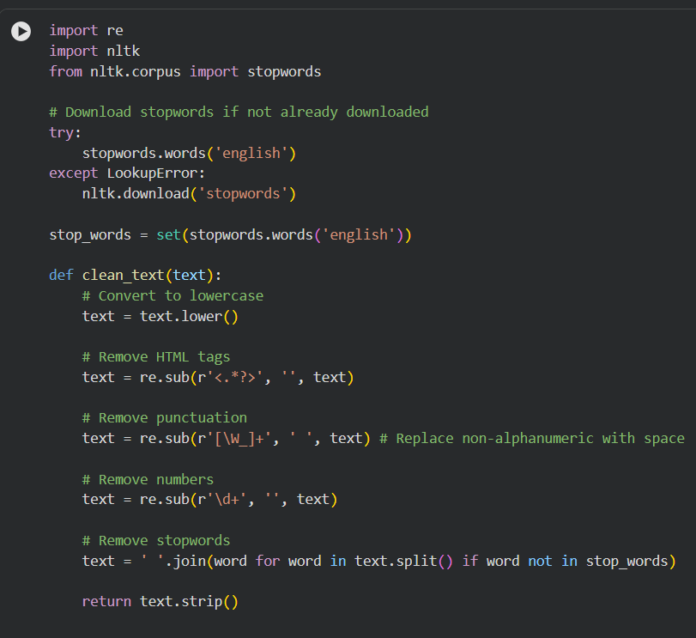  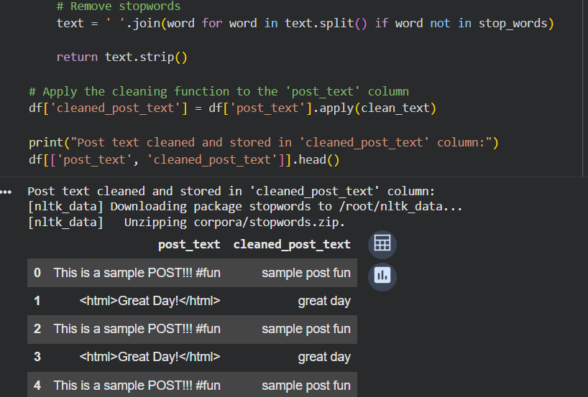  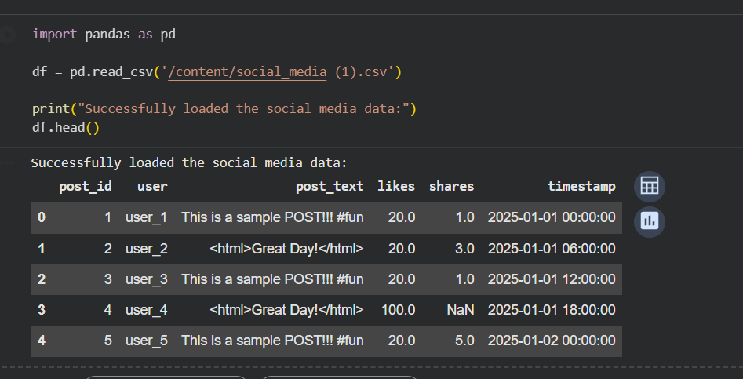  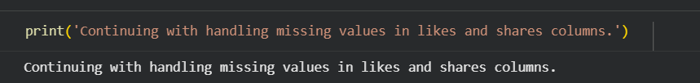  HANDLE MISSING VALUES  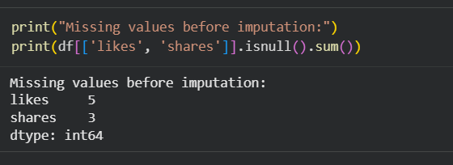  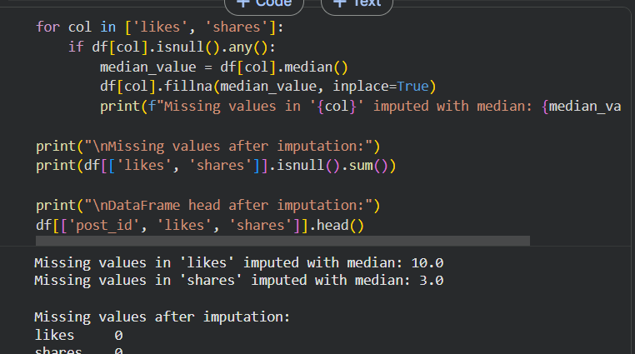  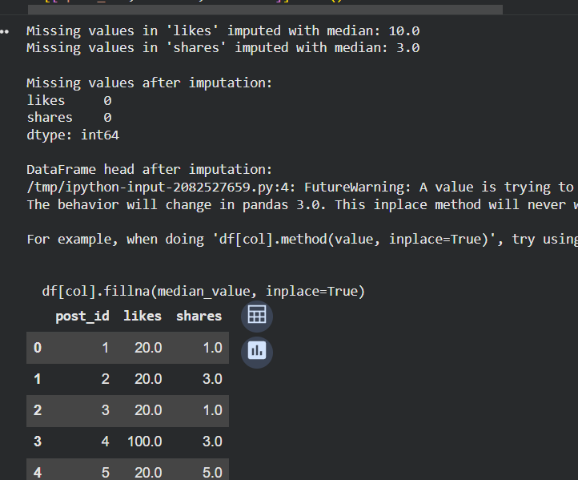  PROCESS TIMESTAMPS:  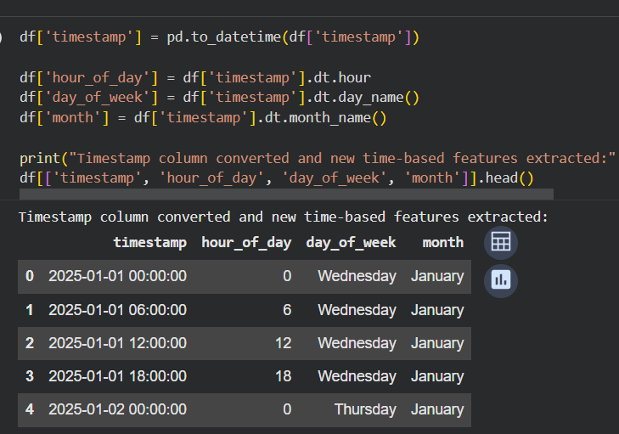  REMOVE DUPLICATES:  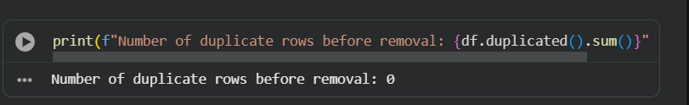  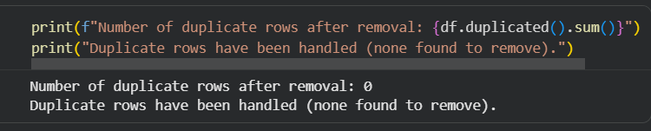  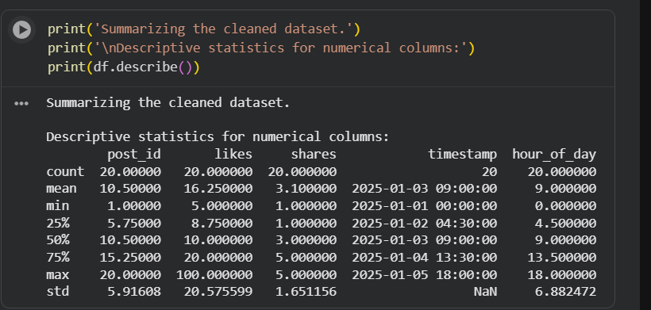  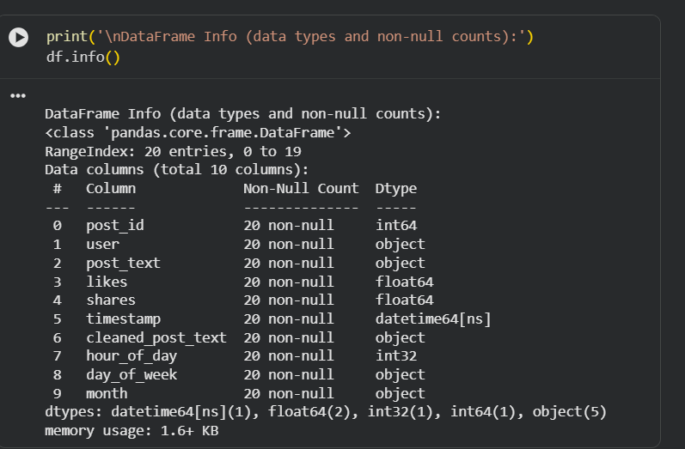  Task 2 – Financial Data Preprocessing  Task: Preprocess a stock market dataset.  Instructions:  - Handle missing values in closing_price and volume.  - Create lag features (1-day, 7-day returns).  - Normalize volume column using log-scaling.  - Detect outliers in closing_price using IQR method.  Expected Output: A time-series dataset ready for forecasting models.  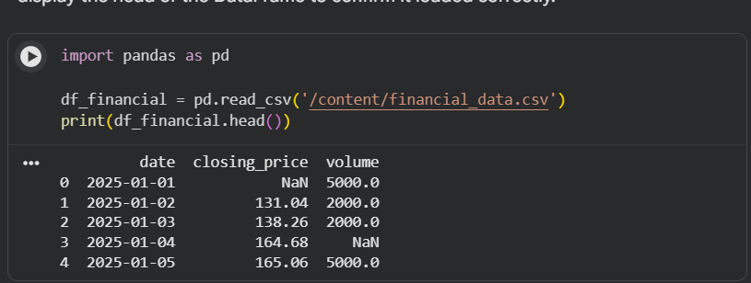  HANDLE MISSING VALUES:  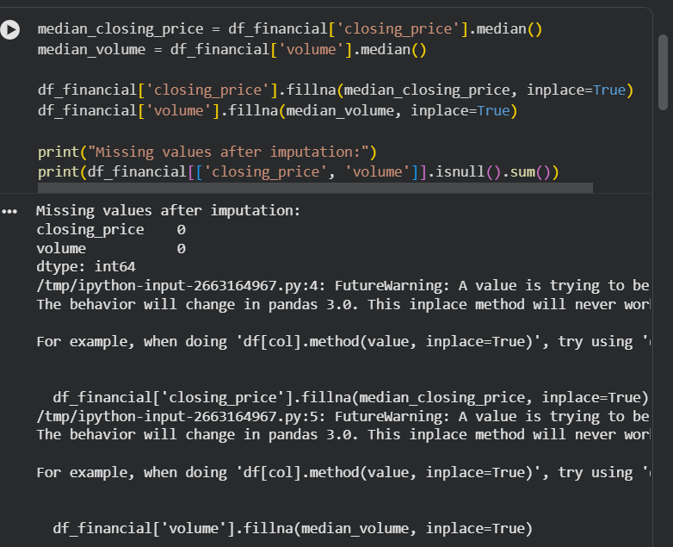  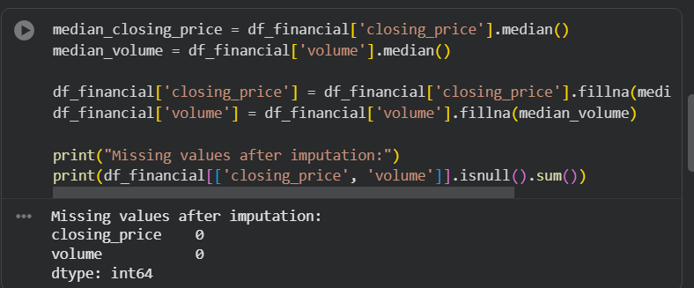  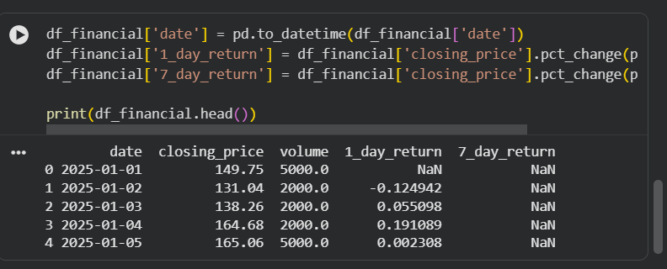  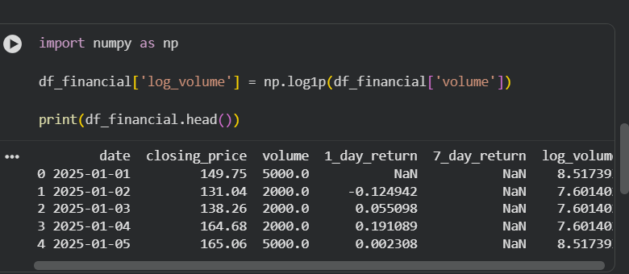  DETECT OUTLIER:  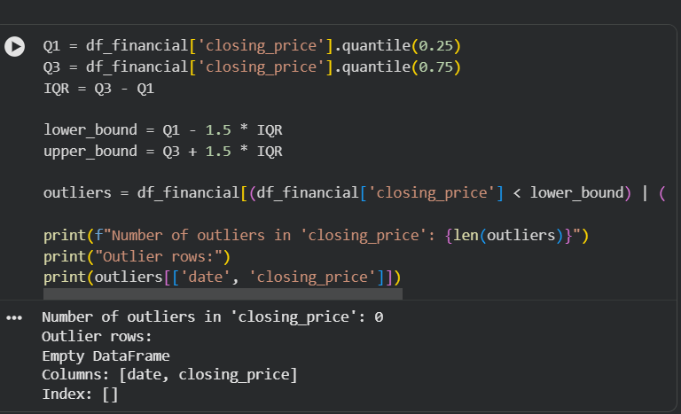  Task 3 – IoT Sensor Data Preparation  Task: Clean and preprocess IoT temperature and humidity logs.  Instructions:  - Handle missing values using forward fill.  - Remove sensor drift (apply rolling mean).  - Normalize readings using standard scaling.  - Encode categorical sensor IDs.  Expected Output: A structured dataset optimized for anomaly detection.  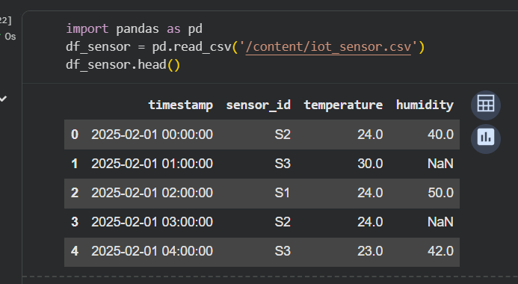  HANDLE MISSING VALUES:  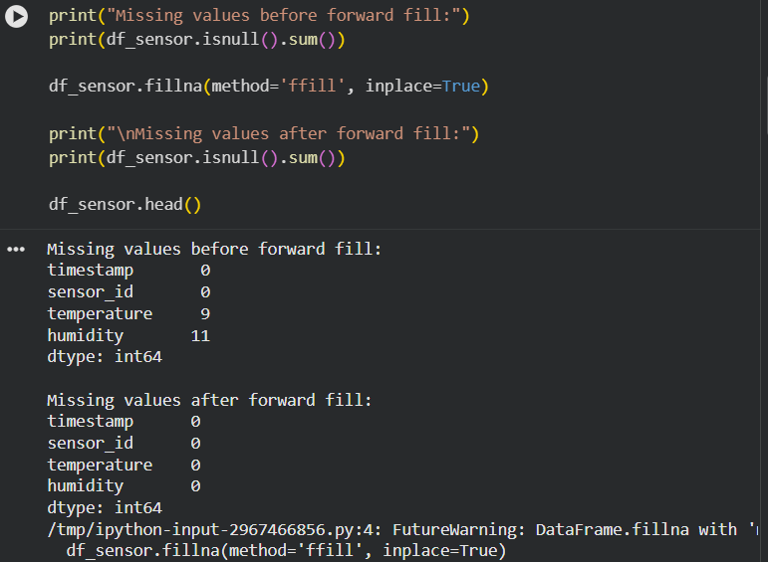  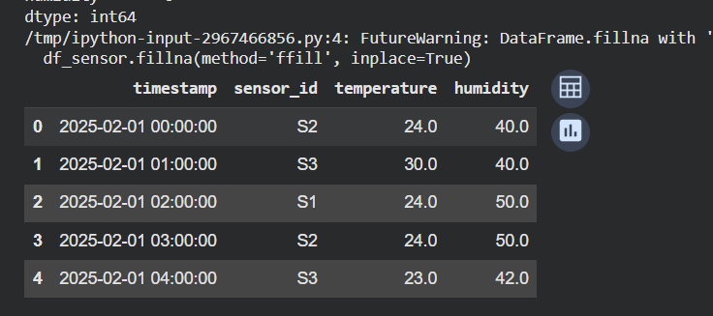  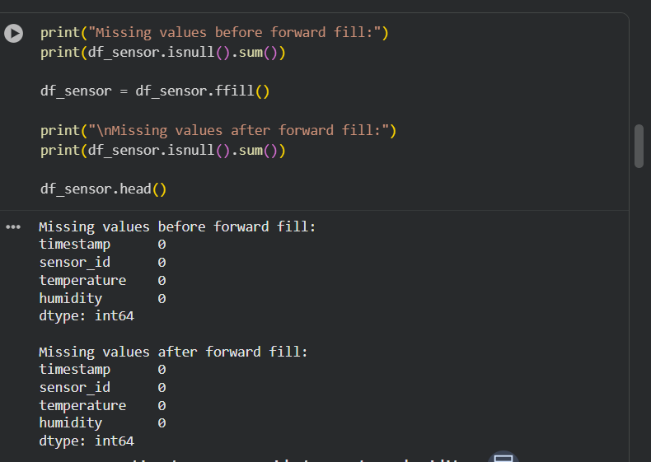  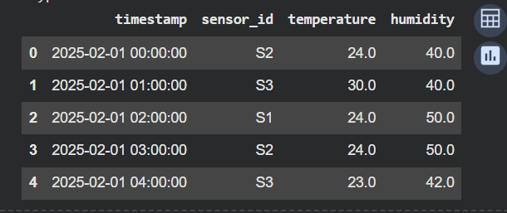  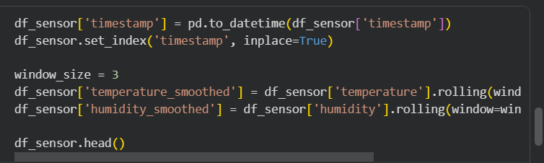  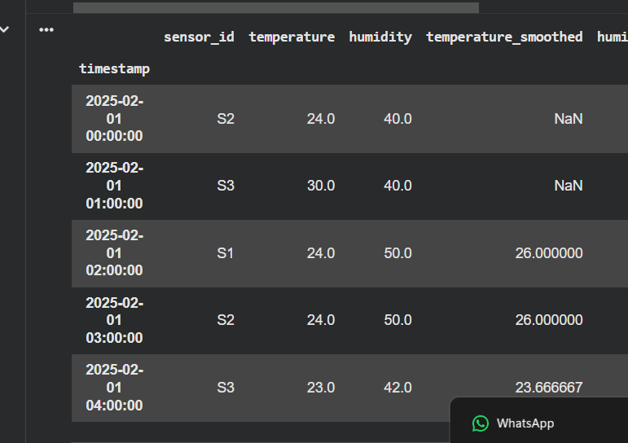  Task 4 – Real-Time Application: Movie Reviews Data Cleaning  Task: A streaming platform wants to analyze customer reviews.  Instructions:  - Standardize text (lowercase, remove HTML tags).  - Tokenize and encode reviews using AI-assisted methods (TF-IDF or embeddings).  - Handle missing ratings (fill with median).  - Normalize ratings (0–10 → 0–1 scale).  - Generate a before vs after summary report.  Expected Output: A cleaned dataset ready for sentiment classification.  ✅ Deliverables (For All Tasks)  - AI-generated prompts for code and test case generation.  - At least 3 assert test cases for each task.  - AI-generated initial code and execution screenshots.  - Analysis of whether code passes all tests.  - Improved final version with inline comments and explanations.  - Compiled report (Word/PDF) with prompts, test cases, assertions, code, and output.  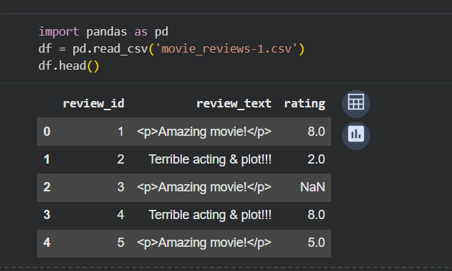  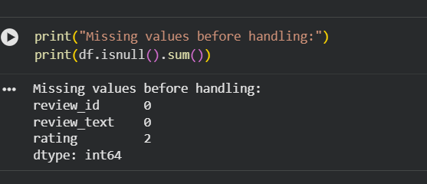  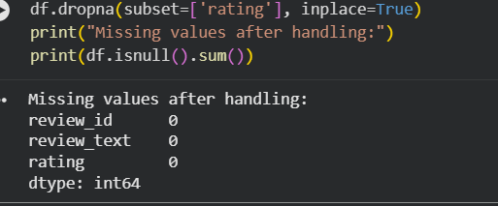  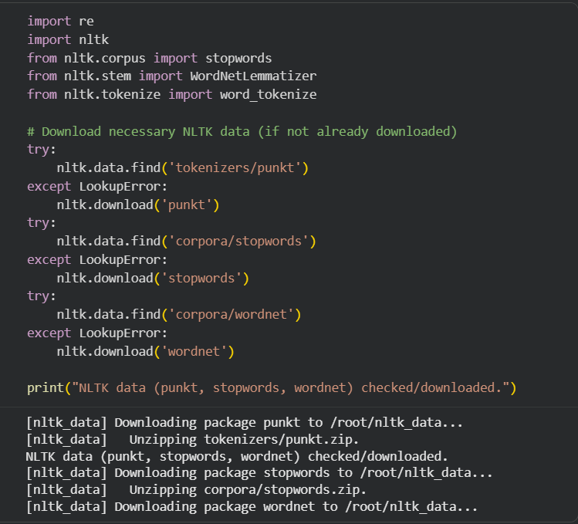  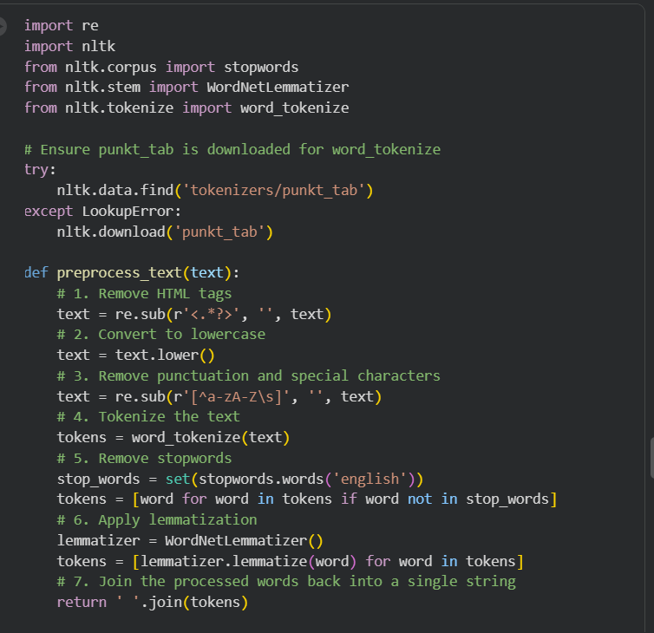  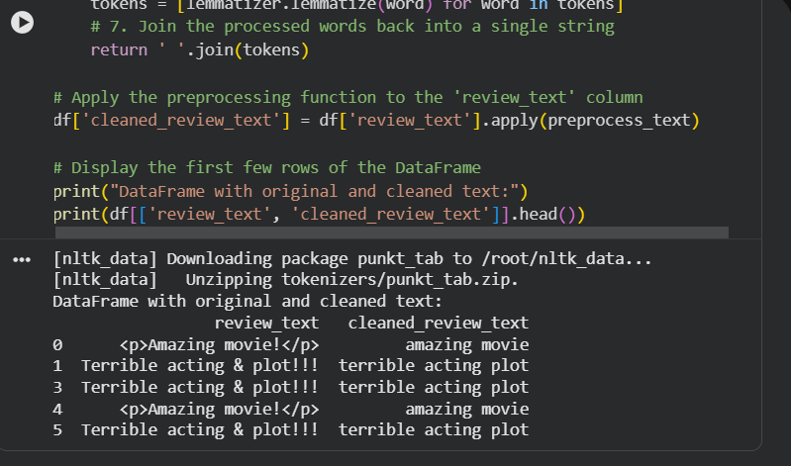  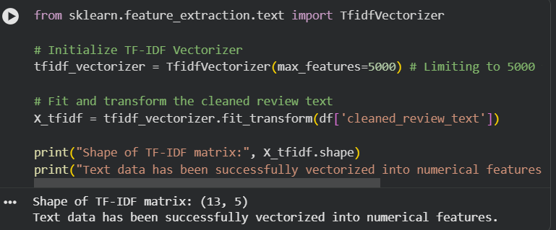  THANKYOU SIR… |  |  |  |  |  | Week9 - Monday

